**Sahosoft Solutions** <https://www.youtube.com/watch?v=3syu_UfCrWM&list=PL_qizAfcpJ-OzjbgGv9xobErKY7v9o0qi&index=1&pp=iAQB>

npm install -g @angular/cli

ng new projectName

ng g c componentName

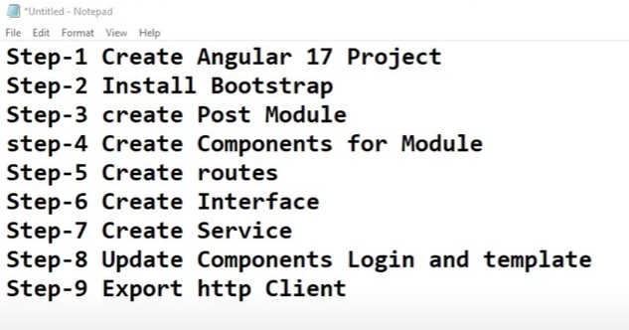

Error: Could not find the '@angular-devkit/build-angular:dev-server' builder's node package.

npm install --save-dev @angular-devkit/build-angular

**topic: preserveWhitespaces**

**topic: viewprovider**

**topic : Encapsulation (for css style)**

**topic : Parent to child Communication With metadata**

**topic: child to parent Communication With metadata**

**topic:Directives (component, styructural,attribute )**

**topic: @If, elseif and else in Angular 17 | Structural Directives**

**topic: @switch and @case in Angular 17 | Structural Directives**

**topic: @for, track, $even, $odd, $first, $last, $count**

**topic: Attribute Directives**

**TOPIC: ngStyle Directives in Angular 17**

**TOPIC:** **ngClass Directives in Angular 17**

**TOPIC: Data Binding in Angular 17**

**TOPIC:interpolation Binding in Angular 17**

**Topic: Singleton Service in Angular 17**

**Topic :** **tree shaking in Service in Angular 17**

# Topic : how router works in Angular 17

# Topic: route configuration in Angular 17

**Topic: wildcard route in Angular 17**

**Topic : how to set base URL in Angular 17**

**Topic:** **Auxiliary Routes in Angular 17 | Named and Multiple Router-Outlets**

**Topic: Routes Guards in Angular 17 | Route Guards (Need to login first when accessing any route)**

**Topic: Auth Guard using Login page in Angular 17 | canActivate Route Guard**

**Generate Guard:**

ng g g guardName



